DSA 0136 OBJECT ORIENRED PROGRAMMING USING C++

12)Write a c++ program for arithmetic operations using switch case and using class and object

using namespace std;

#include<iostream>

class arithmetic

{

int a,b,c,d,e,f,choice;

public:

void getdata();

void putdata();

};

void arithmetic::getdata()

{

cout<<"enter a and b";

cin>>a>>b;

}

void arithmetic::putdata()

{

cout<<"enter choice";

cin>>choice;

switch(choice)

{

case 1:

cout<<"sum of a and b";

c=a+b;

cout<<c;

break;

case 2:

cout<<"sub of a and b";

d=a-b;

cout<<d;

break;

case 3:

cout<<"mul of a and b";

e=a\*b;

cout<<e;

break;

case 4:

cout<<"division of a and b";

f=a/b;

cout<<f;

break;

default:

cout<<"enter correct choice";

break;

}

}

int main()

{

arithmetic y;

y.getdata();

y.putdata();

return 0;

}

Output:

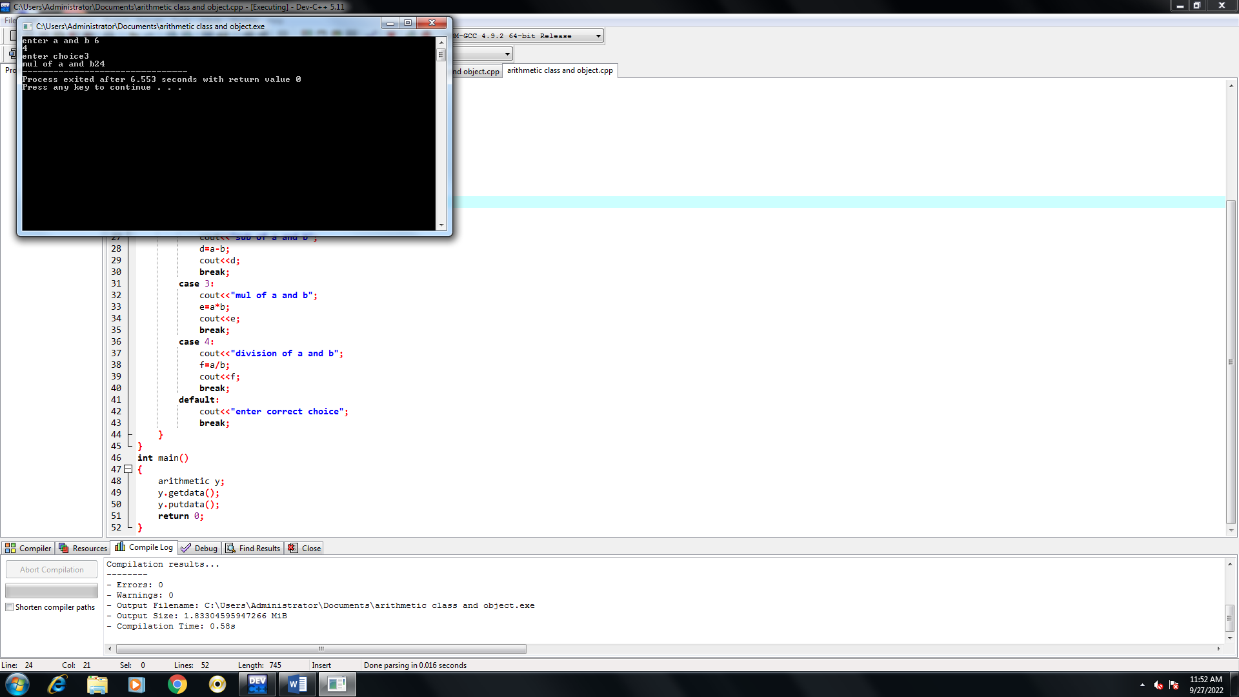

Write a c++program for arithmetic operation using switch case

using namespace std;

#include<iostream>

int main()

{

int a,b,c,d,e,f,choice;

cout<<"enter a and b";

cin>>a>>b;

cout<<"enter choice";

cin>>choice;

switch(choice)

{

case 1:

cout<<"sum of a and b";

c=a+b;

cout<<c;

break;

case 2:

cout<<"sub of and b";

d=a-b;

cout<<d;

break;

case 3:

cout<<"mul of a and b";

e=a\*b;

cout<<e;

break;

case 4:

cout<<"division of a and b";

f=a/b;

cout<<f;

break;

default:

cout<<"enter valid choice";

break;

}

return 0;

}

Output:

